Year 12 Chemistry – Equilibrium Practice Problems

[22 marks]

Name:____________________________

Question 1
(1 mark)

Consider the following endothermic reaction for the production of hydrogen gas in a rigid container:

CH₄(g) + H₂O(g) CO(g) + 3 H₂(g)

Which of the following would increase the Final yield of hydrogen gas?

(a) adding a catalyst

(b) adding inert argon gas

(c) increasing the pressure

(d) increasing the temperature

Question 2

A syringe full of nitrogen dioxide is compressed by a student to the point where no more compression is physically possible. What will the student observe and why? Write a chemical reaction that describes the observation
[3 marks]

____________________________________________________________________

____________________________________________________________________

____________________________________________________________________

____________________________________________________________________

____________________________________________________________________

____________________________________________________________________

____________________________________________________________________

____________________________________________________________________

Question 3

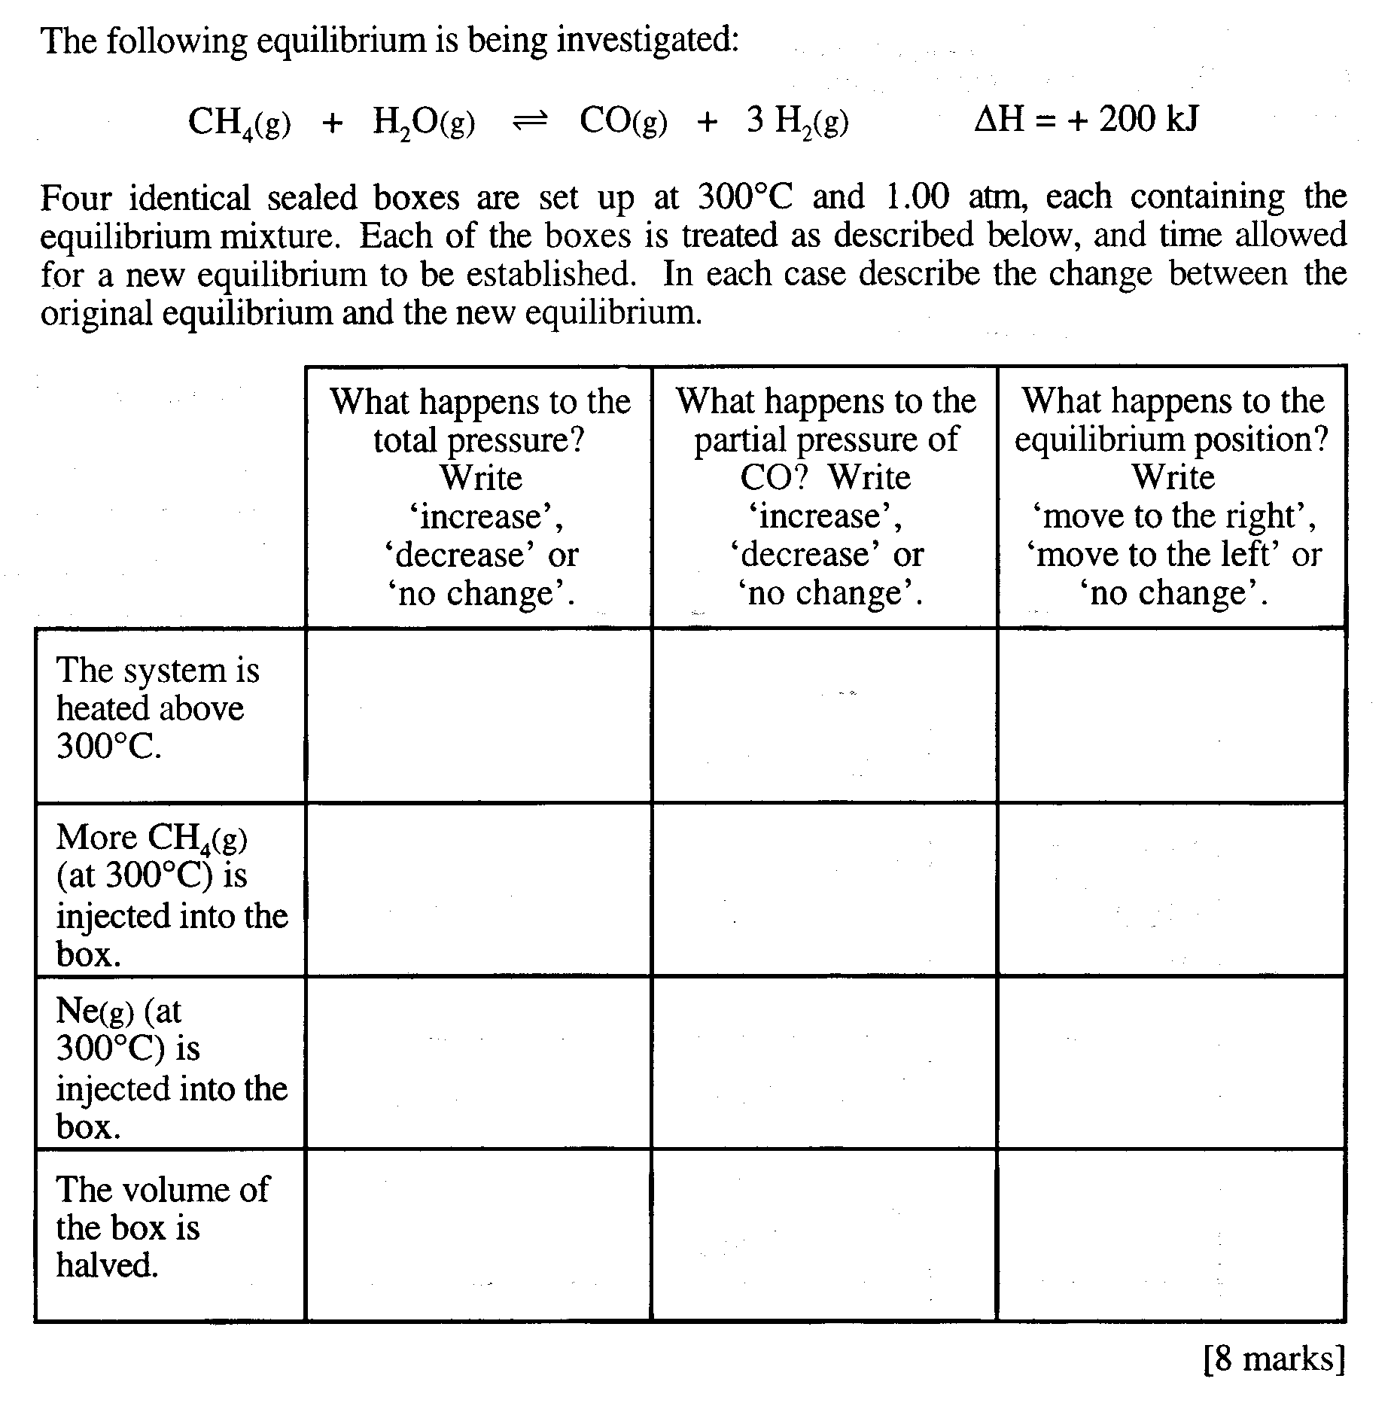

Please Turn Over

Question 4

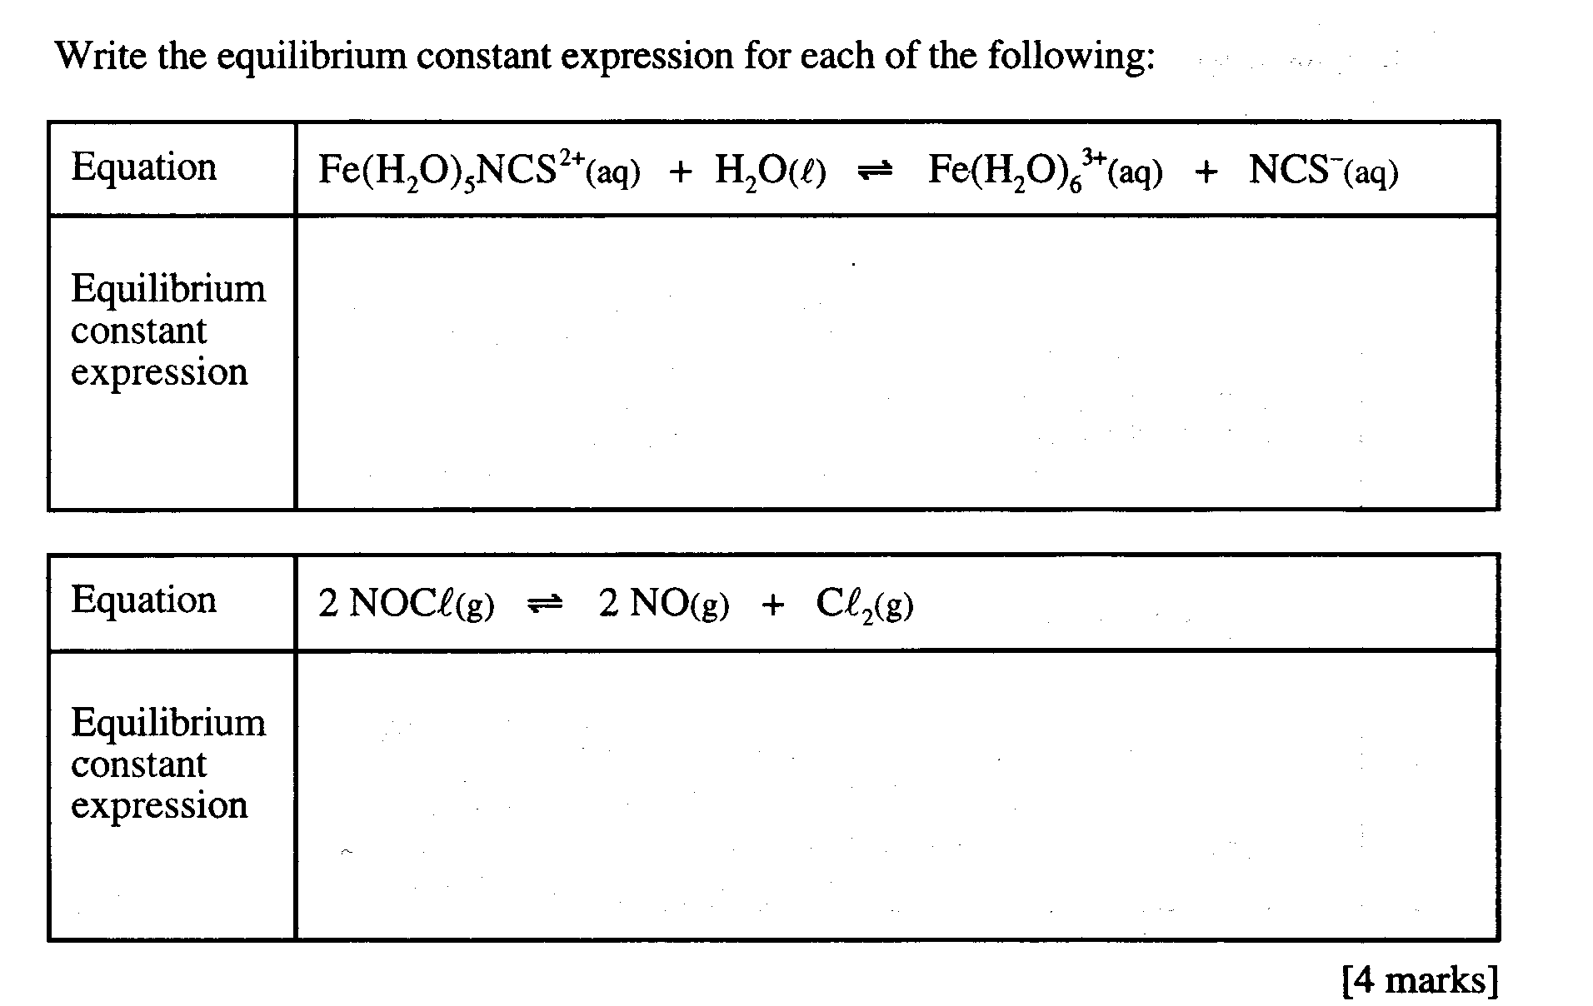

Question 5

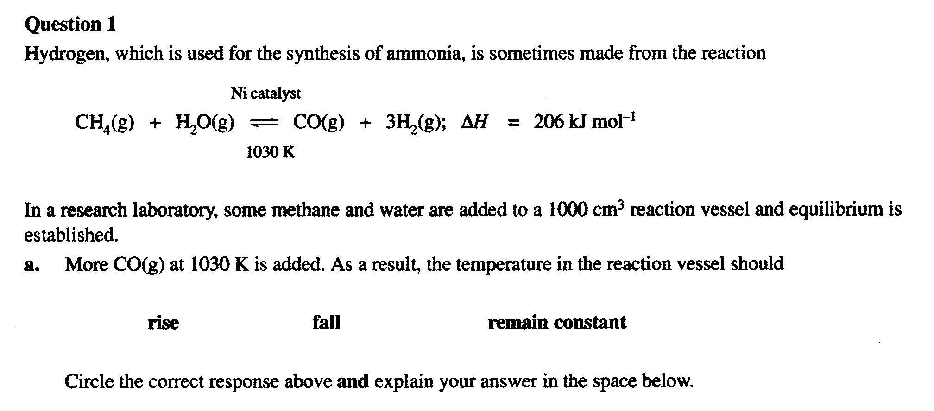
(2 marks)
____________________________________________________________________

____________________________________________________________________

____________________________________________________________________

____________________________________________________________________

____________________________________________________________________

____________________________________________________________________

____________________________________________________________________

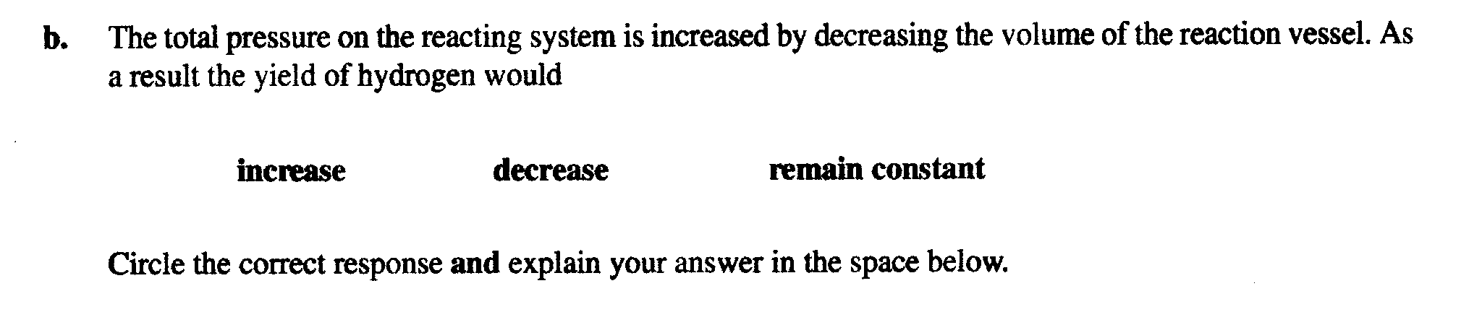
(2 marks)
____________________________________________________________________

____________________________________________________________________

____________________________________________________________________

____________________________________________________________________

____________________________________________________________________

____________________________________________________________________

____________________________________________________________________

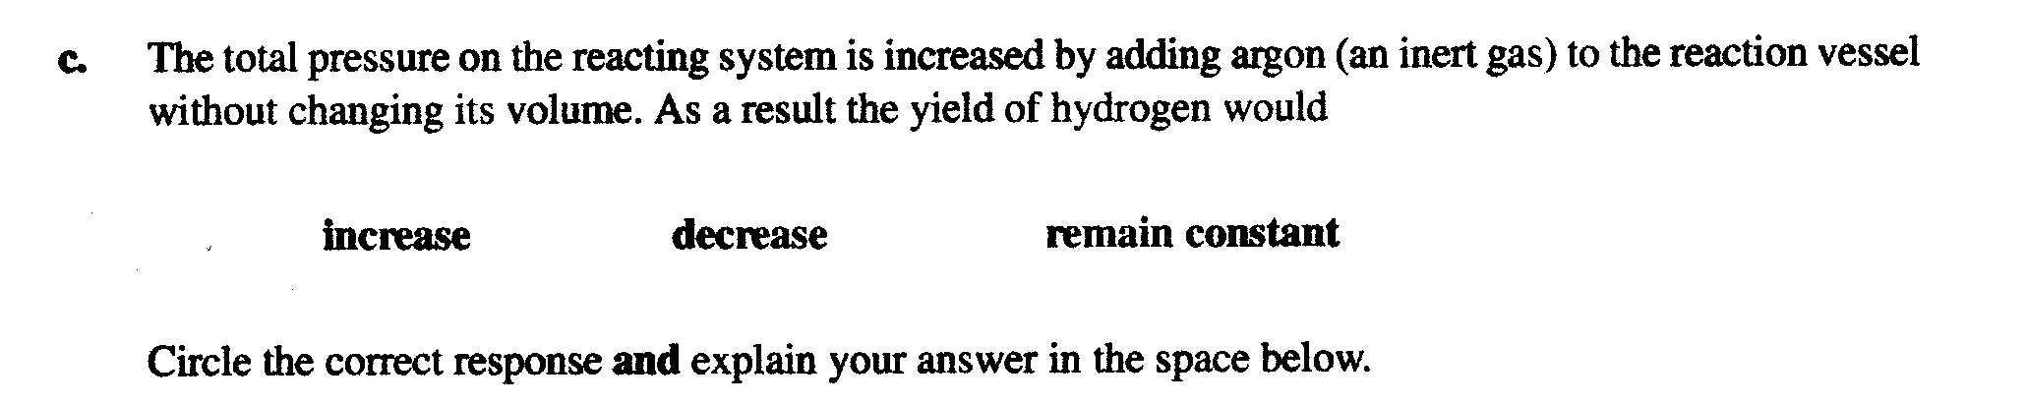
(2 marks)
____________________________________________________________________

____________________________________________________________________

____________________________________________________________________

____________________________________________________________________

____________________________________________________________________

____________________________________________________________________

____________________________________________________________________

